Task Scheduler

1. 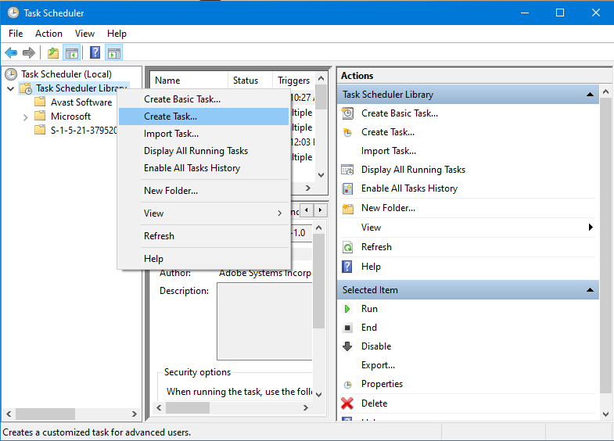Right Click Task Scheduler Library and select Create Task…
2. General Tab

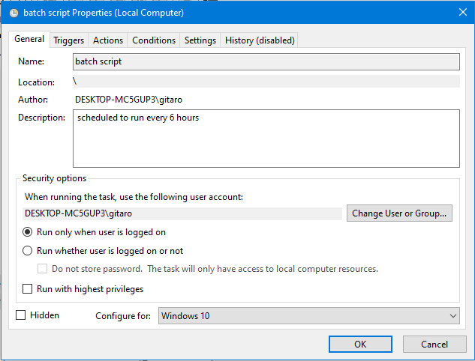

1. Triggers Tab

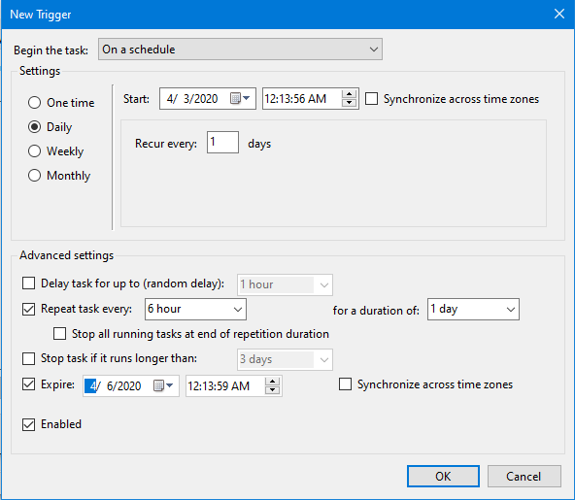

1. 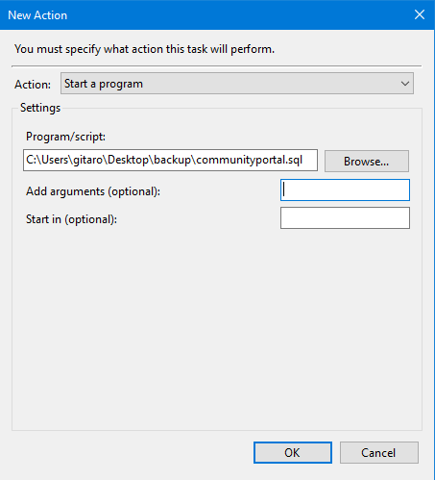Action Tab
2. Conditions Tab

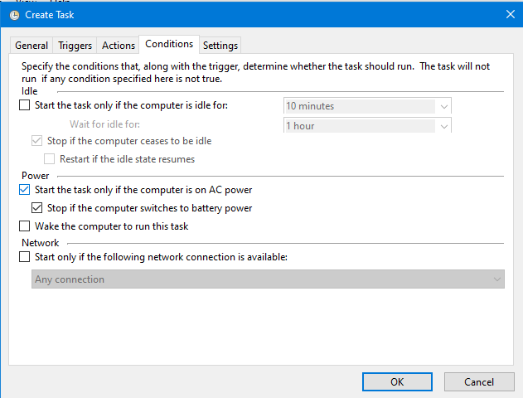

1. 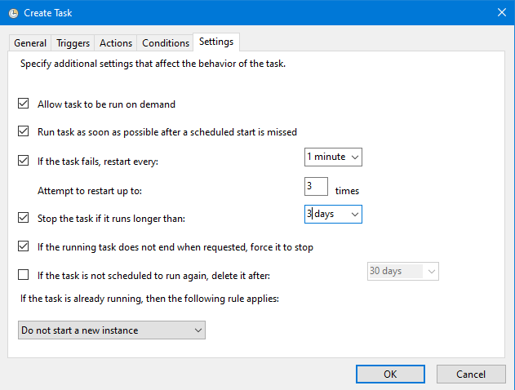Settings Tab
2. 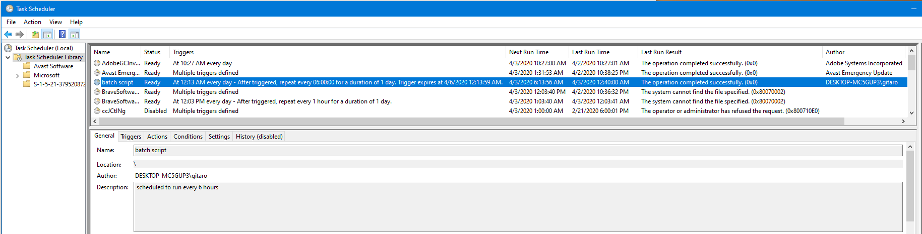batch script – Status -> Ready
3. 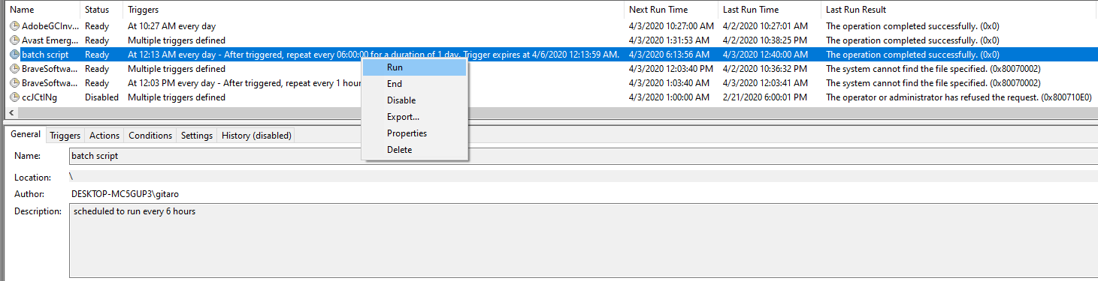batch script – Status -> Ready
4. Open with MySQL Workbench

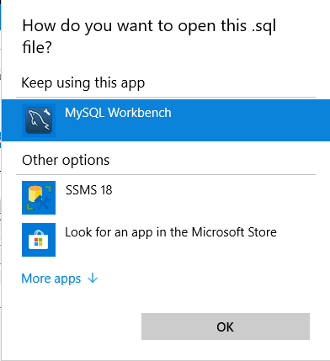

1. 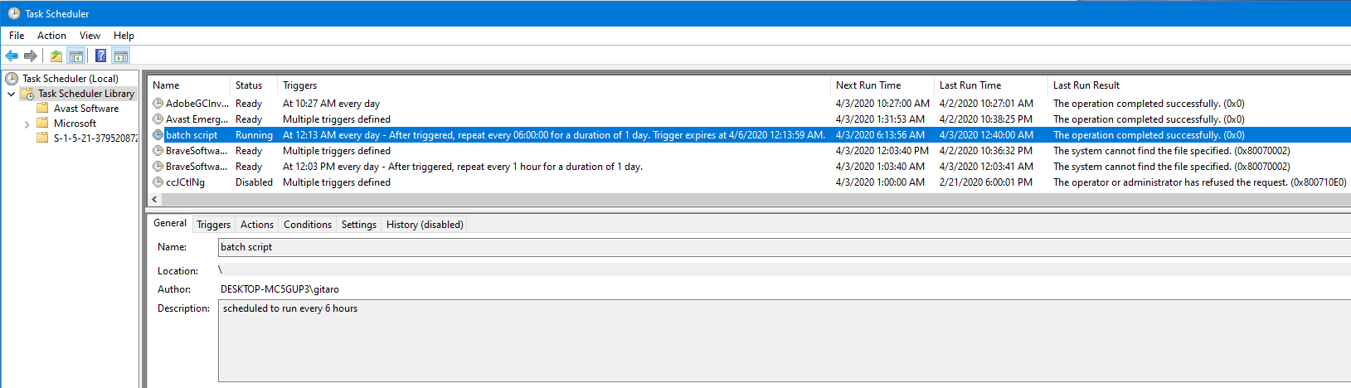batch script – Status -> Running